**WEEK I:**

**Sample space**: All possible outcomes of an experiment

**Event**: Subset of sample space

**Simple event**: Particular outcome of an experiment

**Null event:**

**Interpretations of set notation in probability theory:**

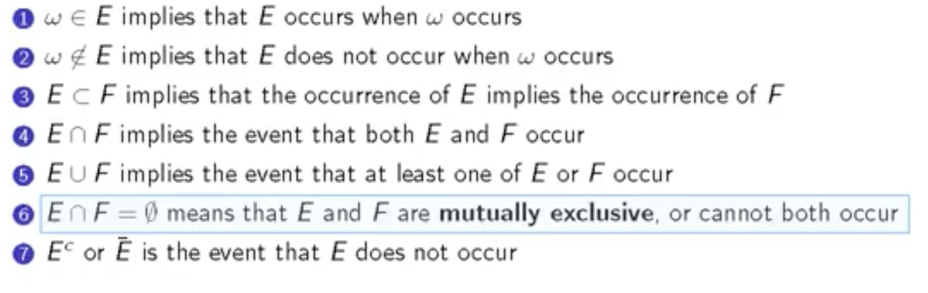

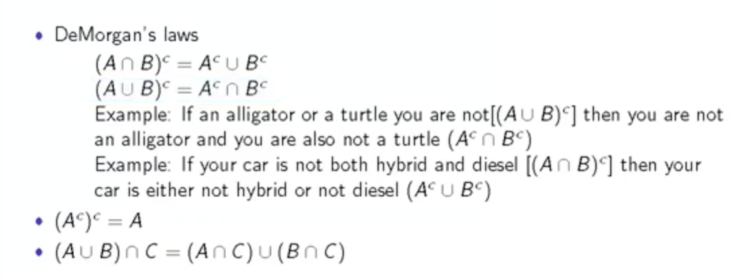

**Rules for a probability function**

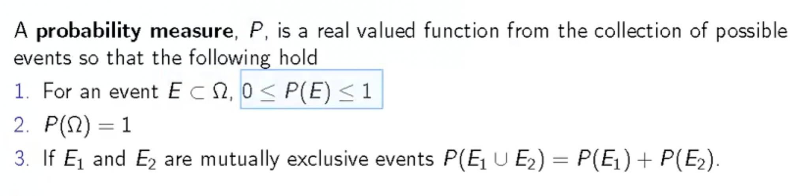

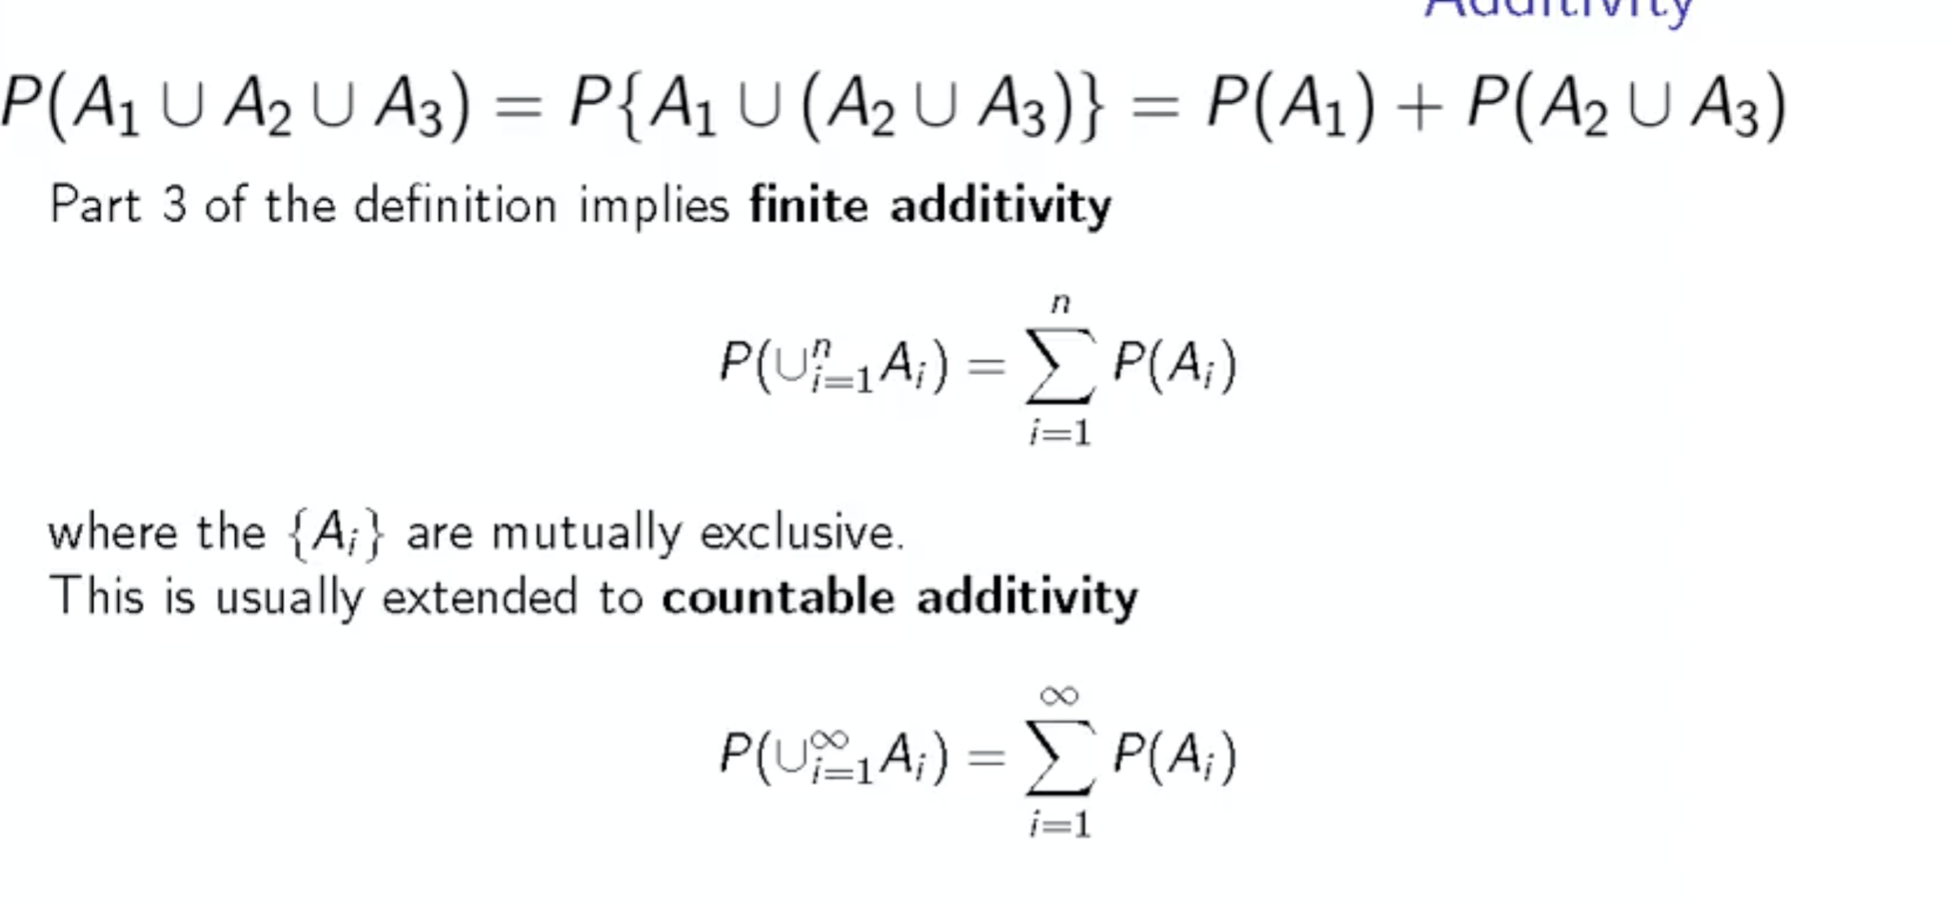

**Random variables**

Outcome of an experiment with prob associated with them

Discrete and continuous

**PMF, PDF**

Probability mass function gives the probability of an outcome generated by a discrete random variable

Probability distribution function does the same for a continuous random variable

**CDF, Survival function:**

Function that defines probability for the value lesser than specified value is CDF or cumulative distribution function

And opp of cdf i.e. prob for value greater than specified x is Survival function

**Quantile:**

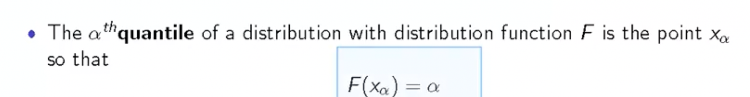

**Expected value E[X]**

It gives the mean, or physically centre of mass

**Properties of expected value:**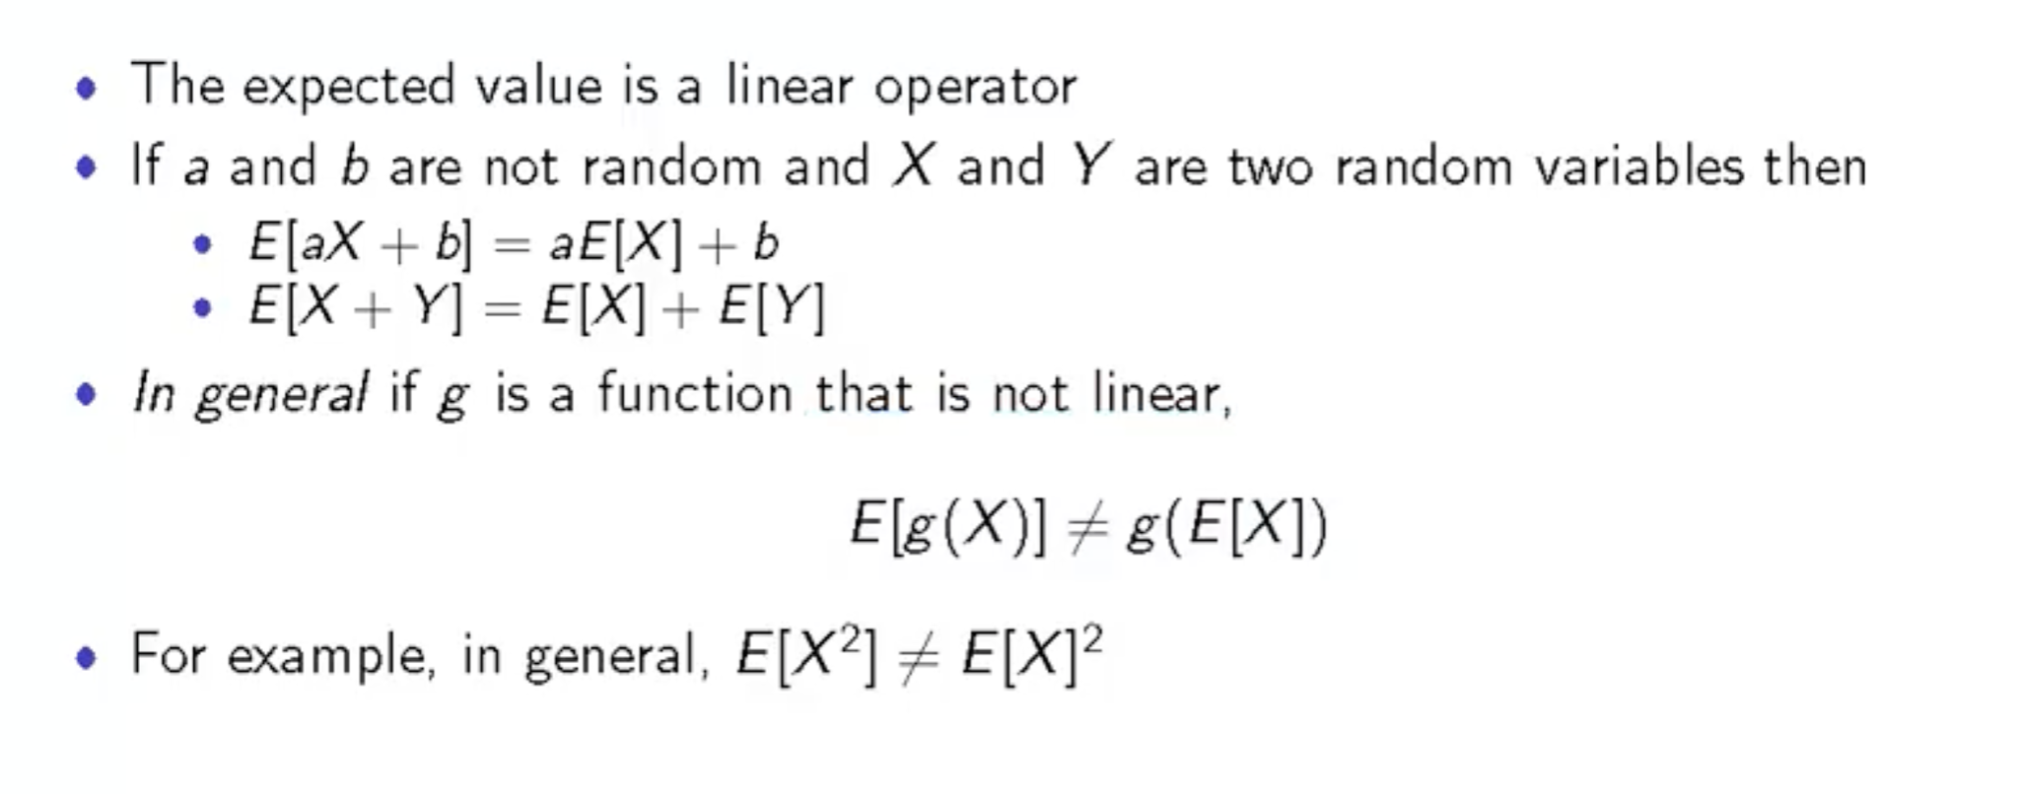

**Expected value of the sample mean is the population mean**

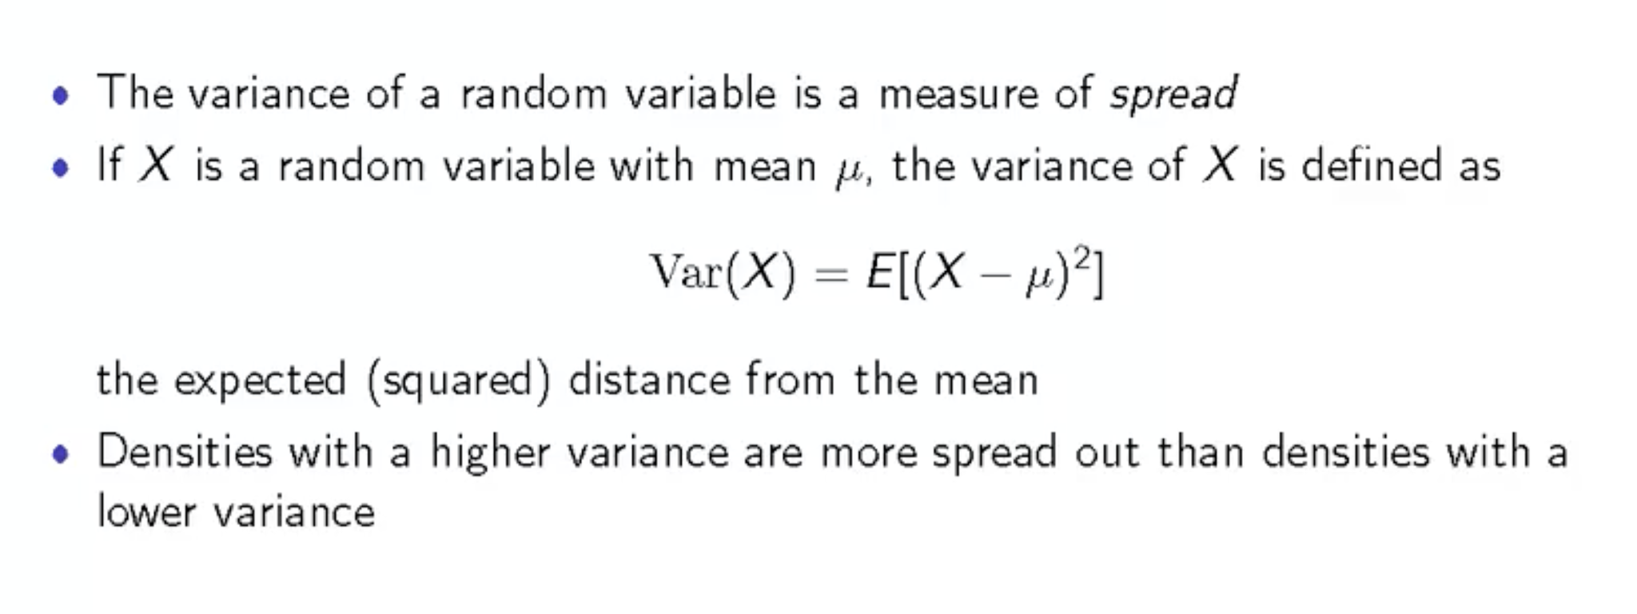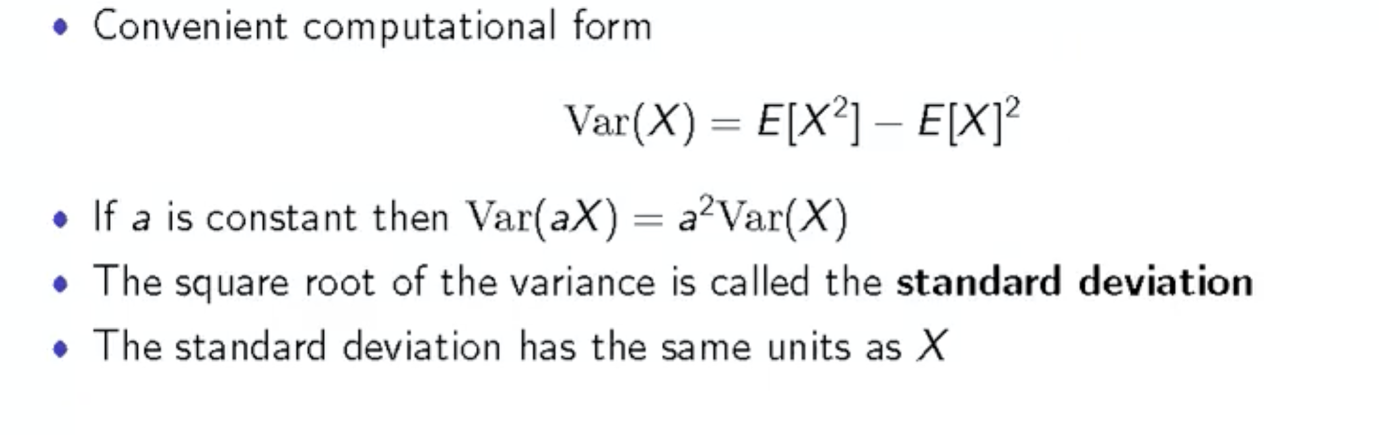

**Variance is not a linear variable**

**Standard deviation is used over variance because it has same units as random variable**

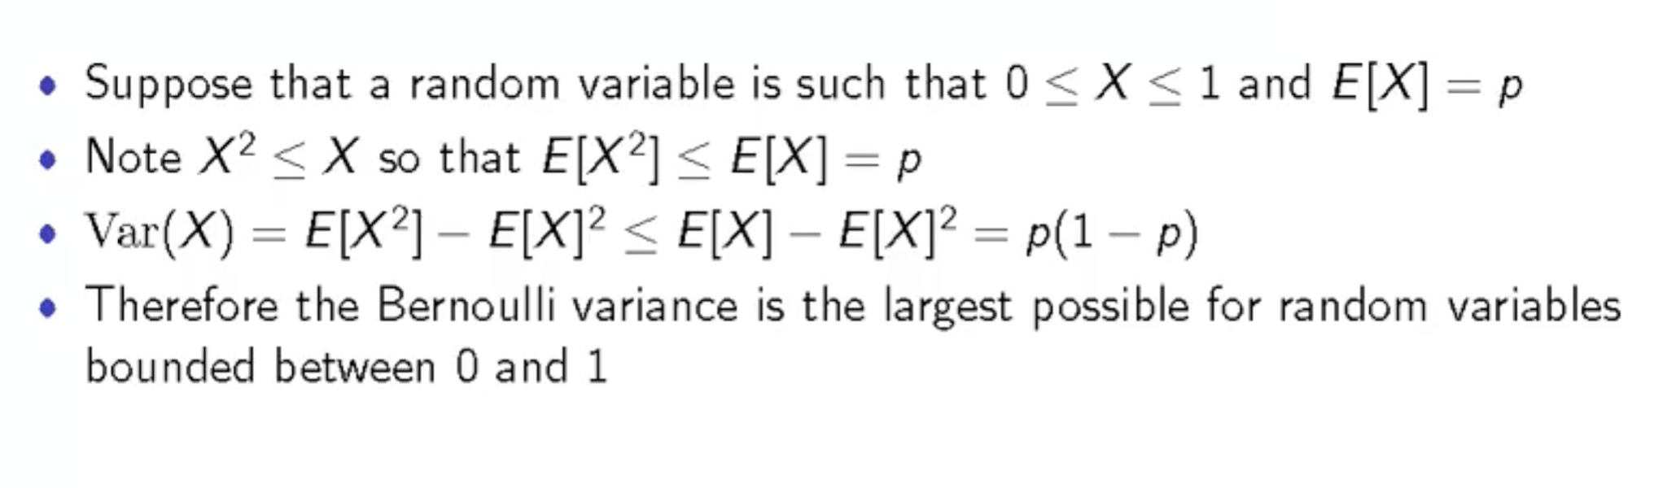

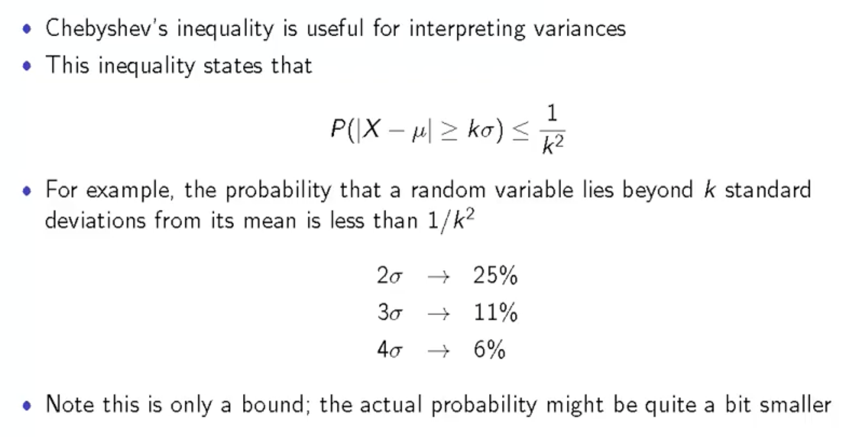

**INFERENTIAL STATISTICS**

**Type I error: alpha** - Significance level: prob to Reject the Null when it is true

**Type II error Beta** - Donot reject Null when alternative is true

We accept the null hypothesis if the p value or prob of obtaining the result we obtained is greater than significance level.

Statistics have 2 framework

Frequentist: Inference is fixed from start and Bayesian: Inference modifies after experiment

**List Vs Numpy arrays**

Numpy arrays have to have the same data type unlike lists thus data type of an element need not be stored always.

Numpy arrays are faster than lists.

For Numpy arrays operation on complete array can be performed but not for list

Dictionaries are useful for data frames.

Pd.dataframes can create columns of values

Lambda functions: No name, always returns something, but can be assigned to a variable

F = lambda x: np.sin(x)

X = np.linspace(-np.pi, np.pi, 100)

Y = f(i for i in X)

plt.plot(x,y)

Plt.show

**Confidence interval is Best estimate +- Margin of error**

Best estimate is based on responses and Margin of error is based on confidence interval

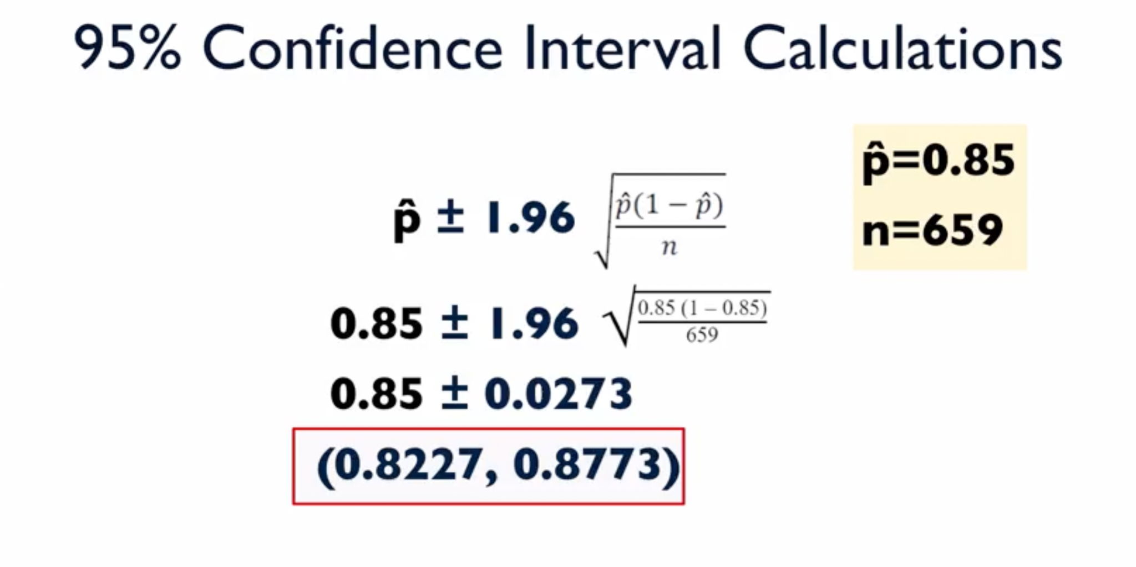

P hat is the best estimate; 1.96 is based on 95% confidence.

82.27 and 87.73 % gives us a confidence interval here with 95% confidence.

Confidence interval with 95% confidence means that best estimate of population is present in the interval of sample.

Multiplier for 98% confidence is 2.326 and 99% is 2.576

Seeing theory:

As the sample size increase the width goes on decreasing and as the confidence level increase the width again goes on increasing

**Assumptions for a Population confidence interval**

Random sample

Large enough sample size, so that we can approximate the sampling distribution with normal curve because multiplier i.e. 2.326 is from normal distribution

To check if sample is large enough check if we have at least 10 entries for each response

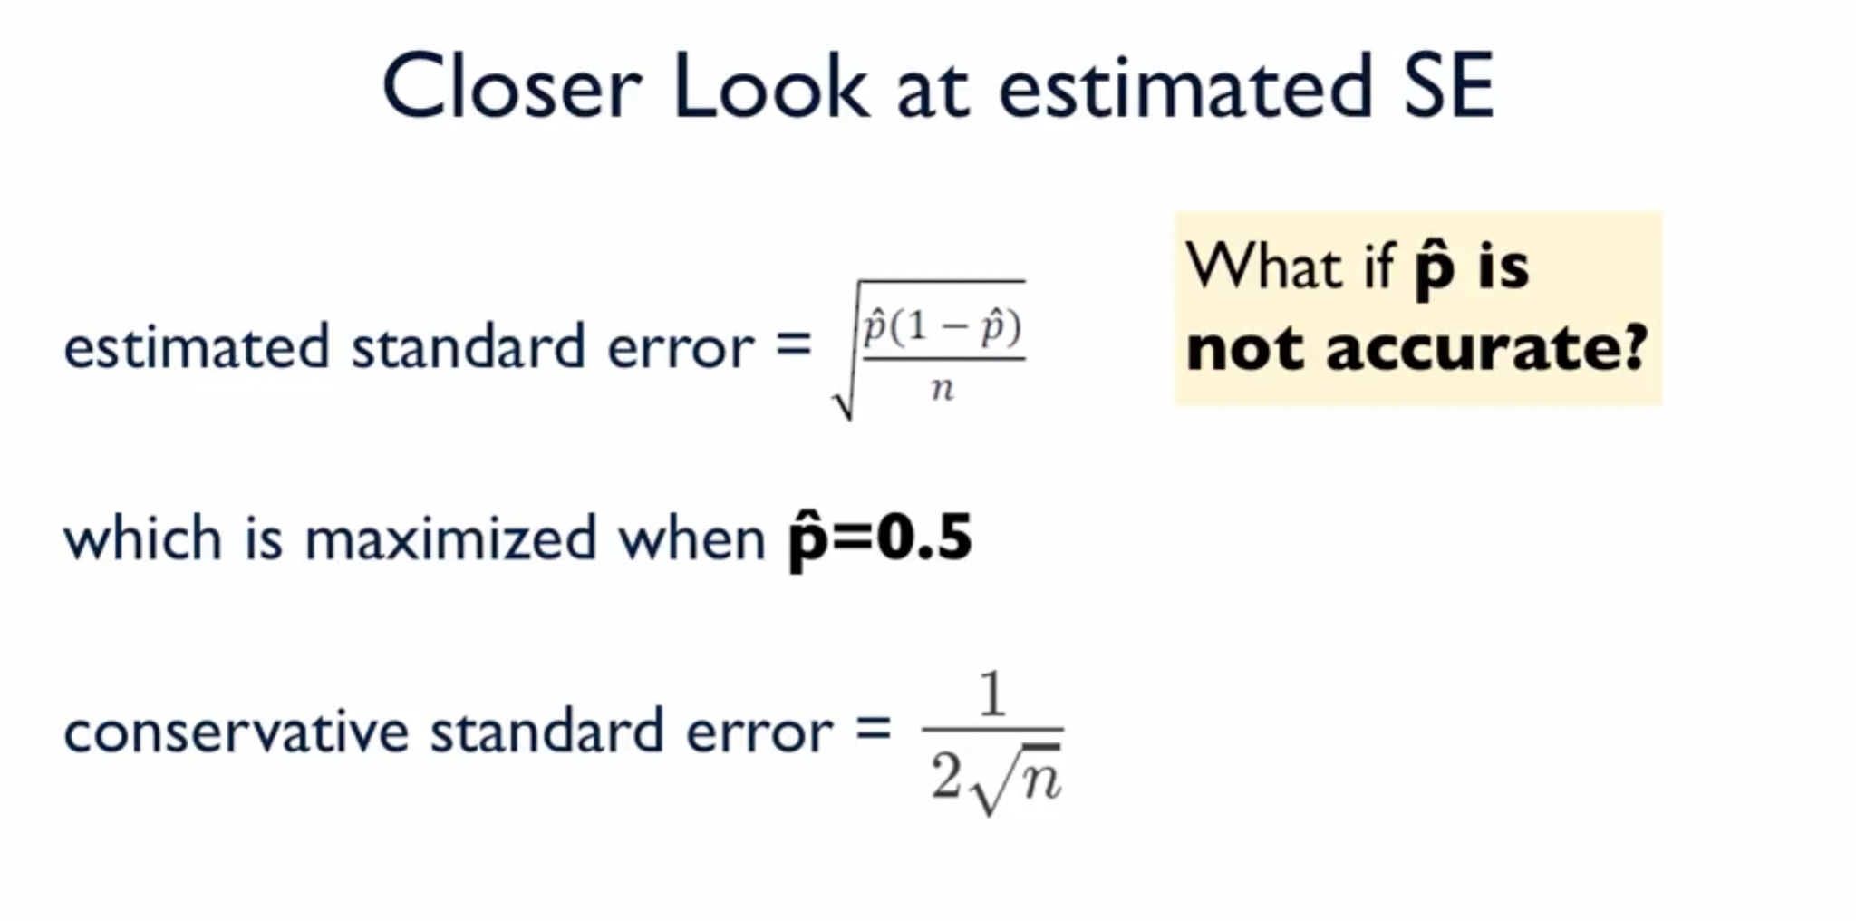

Conservative approach is maximizing the margin of error. That is when we plot p(1-p) we get max error at p =0.5 which is a conservative margin of error. Whenever the error is too small or inaccurate because of the sample, we used this approach.

Required sample size can be determined depending on the confidence level and margin of error required.

**Difference in population proportion with confidence**

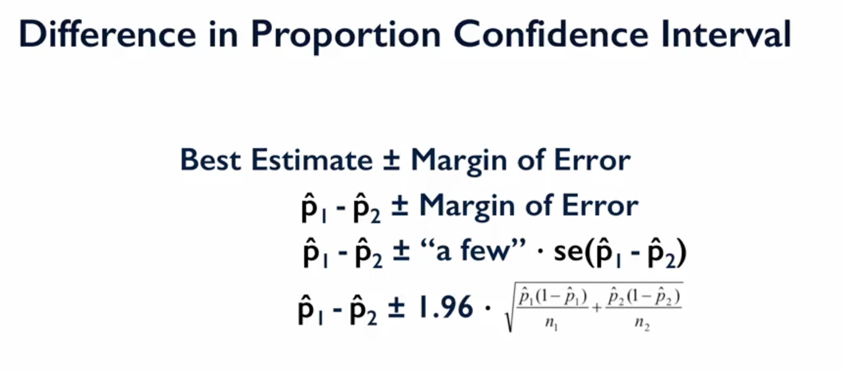

**Estimating population mean**

Standard error or the standard deviation for population mean is the Standard deviation for population divided by root of sample size. But standard deviation for the population can never be calculated and so we use sample standard deviation and calculate estimated standard error for population mean

**Mean difference in paired data**

Same as mean for single data group

**Difference of population mean for independent group**

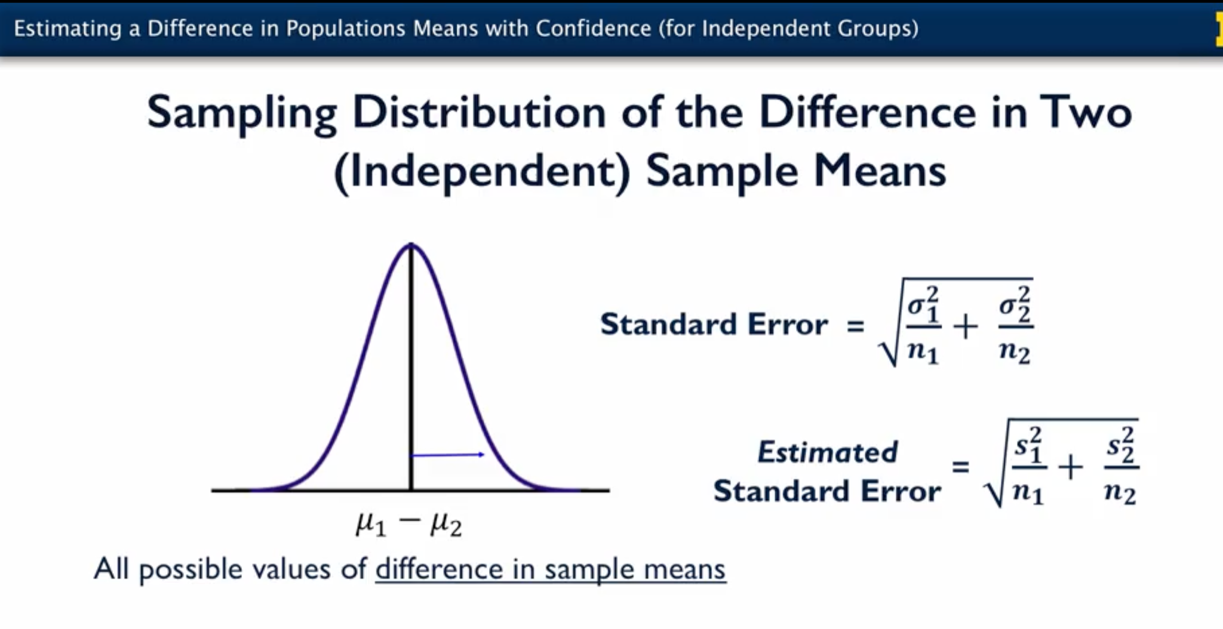

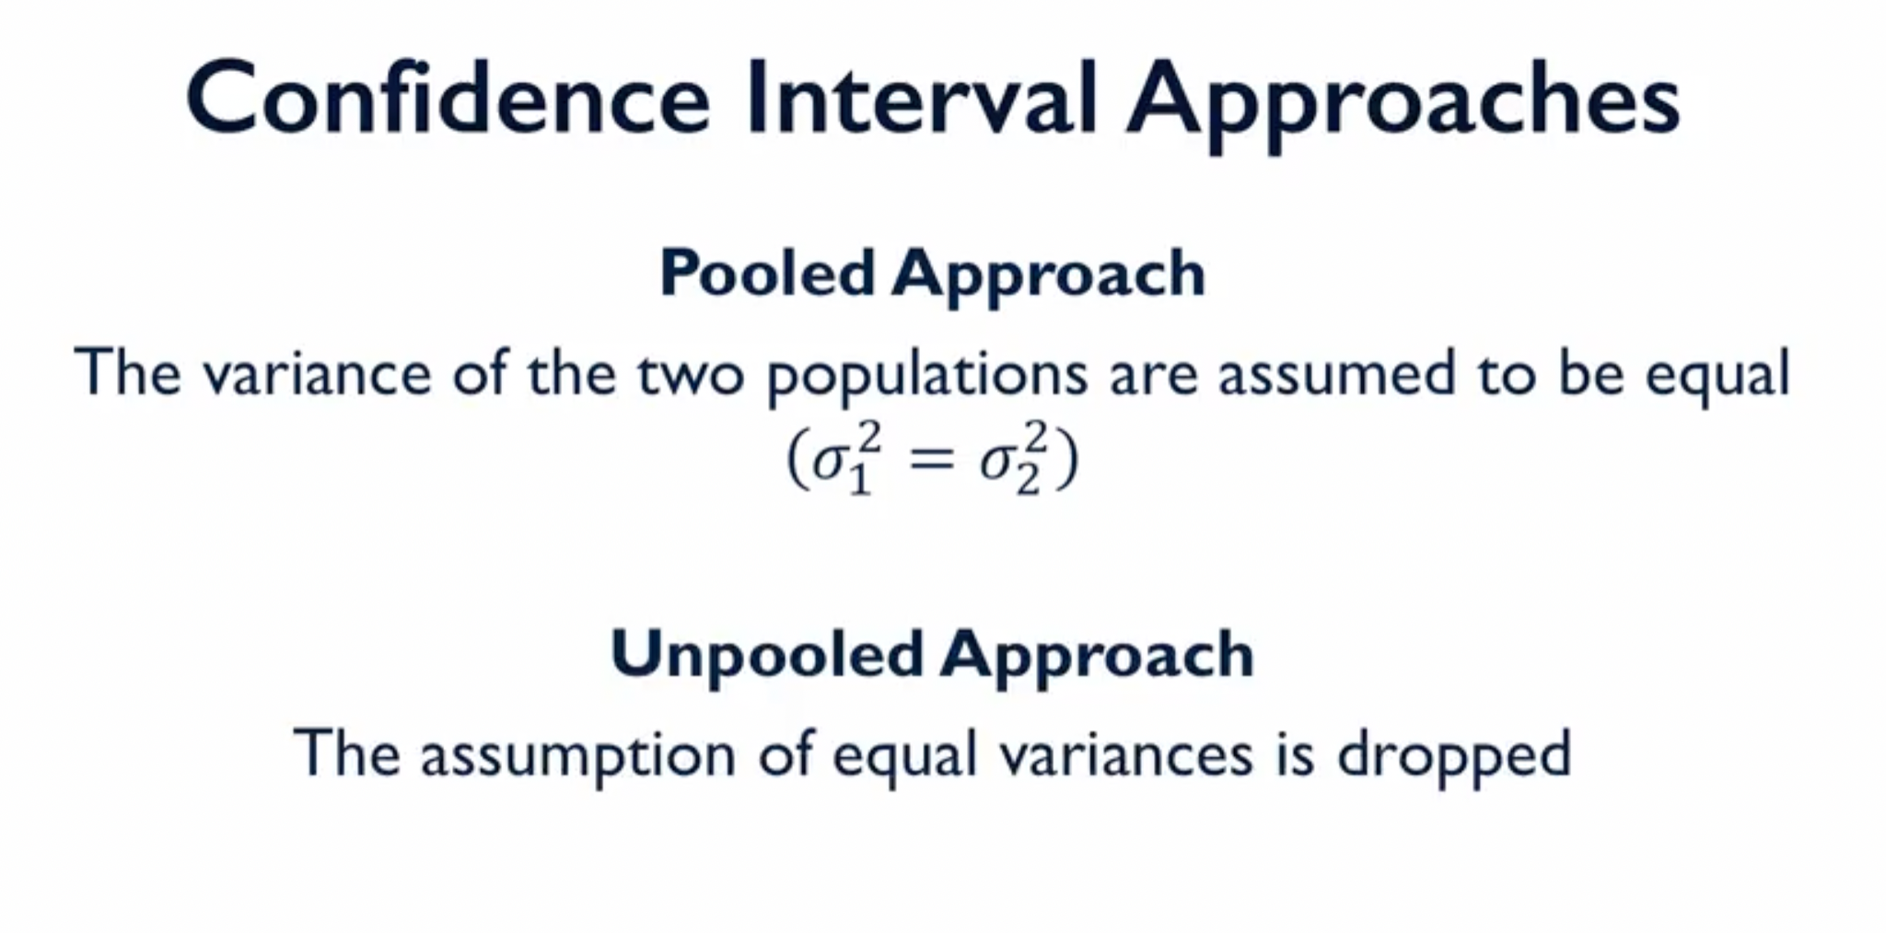

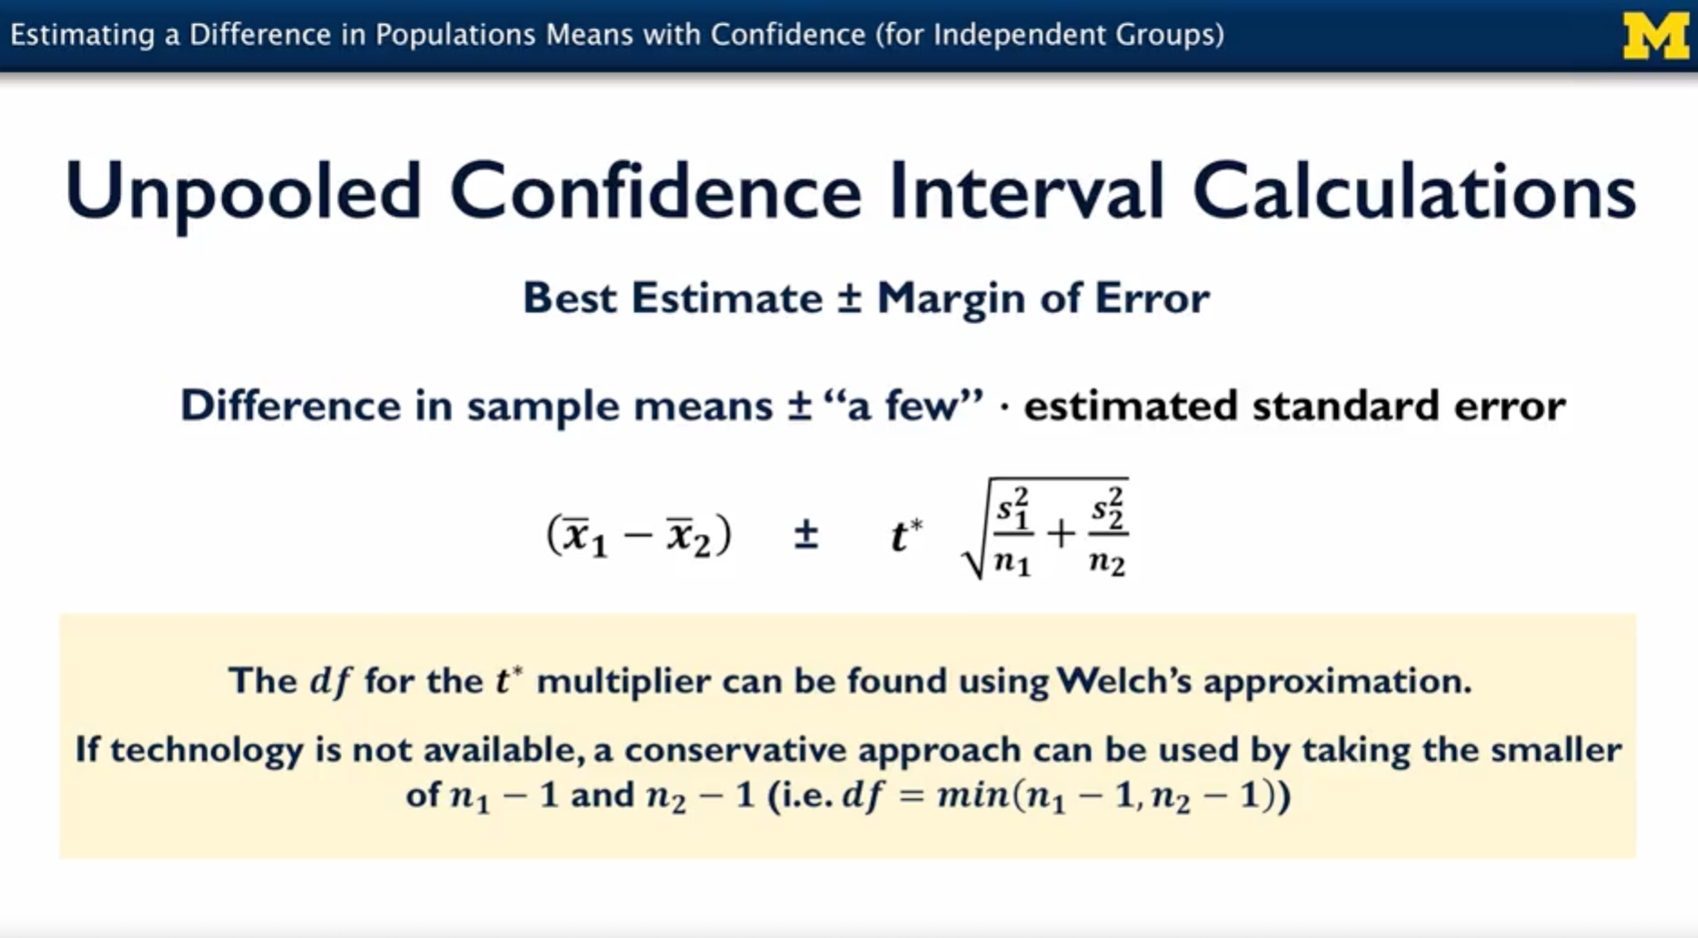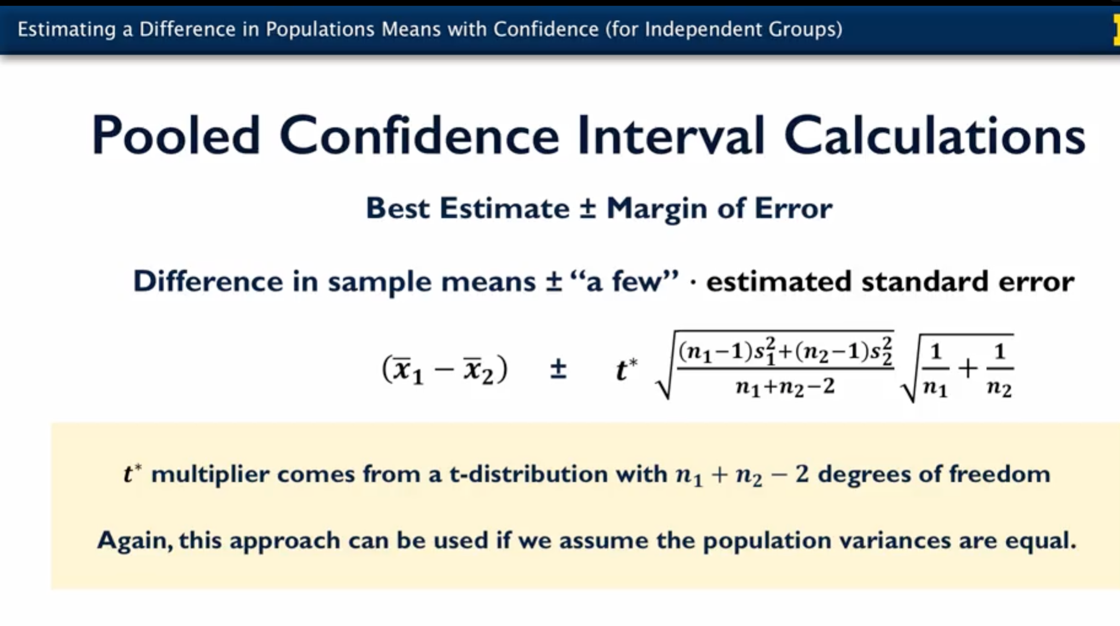

Standard proportion is calculated differently for population proportion and mean

**POPULATION PROPORTION WITH CONFIDENCE**

import statsmodels.api as sm

sm.stats.proportion_confint(n * p, n)

**MEAN CONFIDENCE INTERVAL**

sm.stats.DescrStatsW(df["CWDistance"]).zconfint_mean()

**WEEK III: Testing the hypothesis:One population proportion**

Define the null and alternative hypothesis:

Determining Test statistic

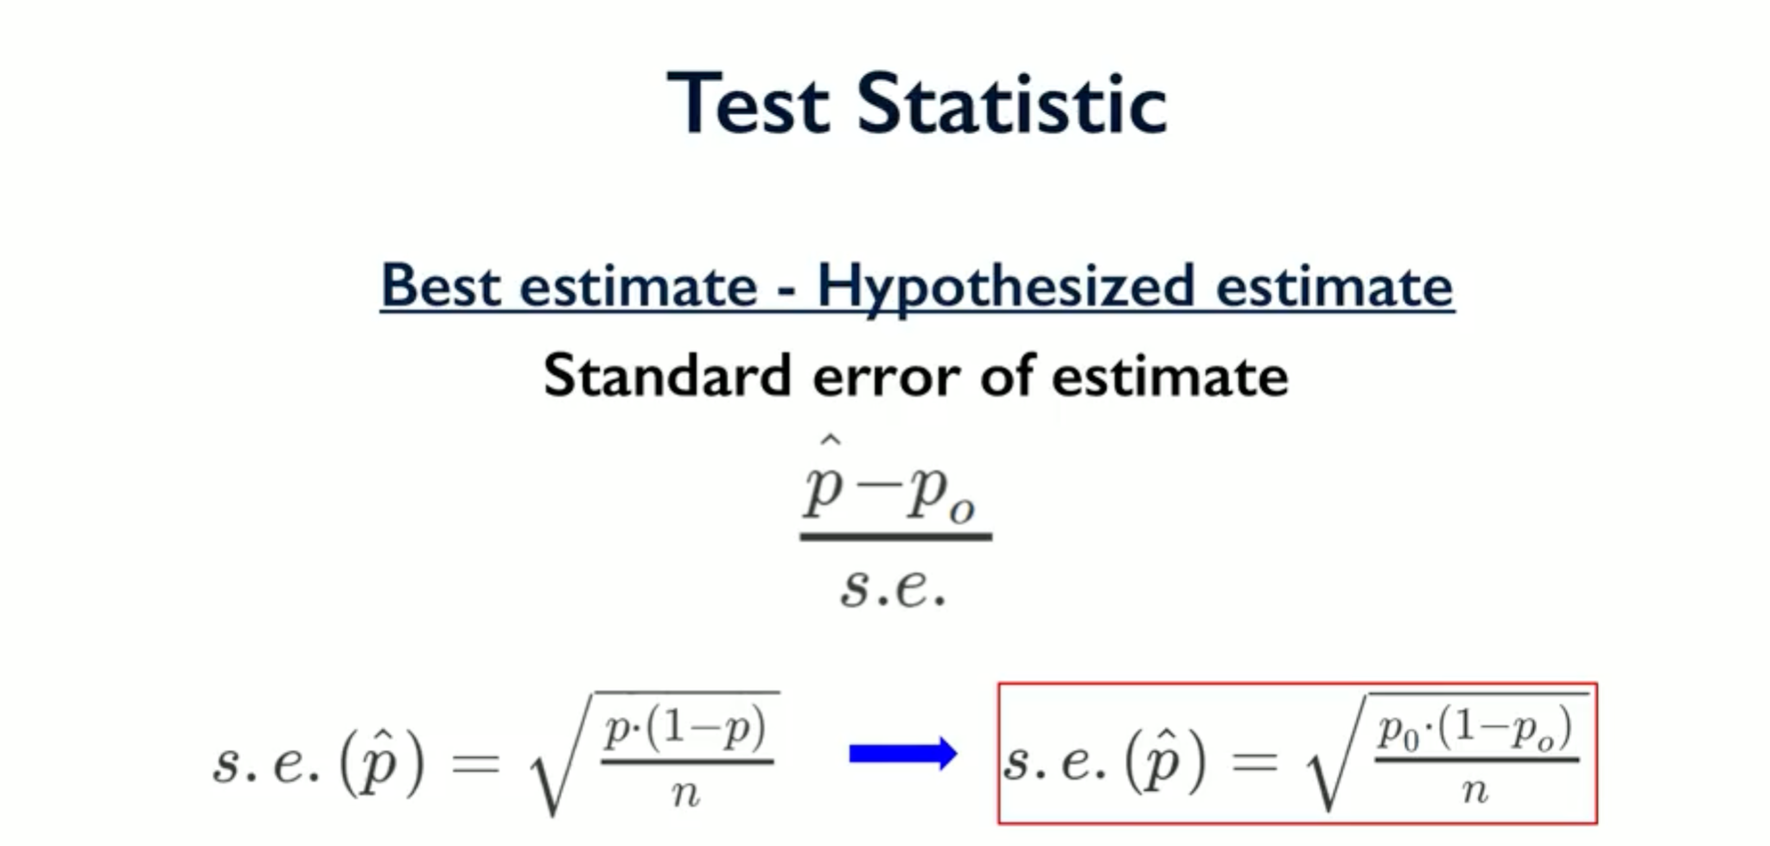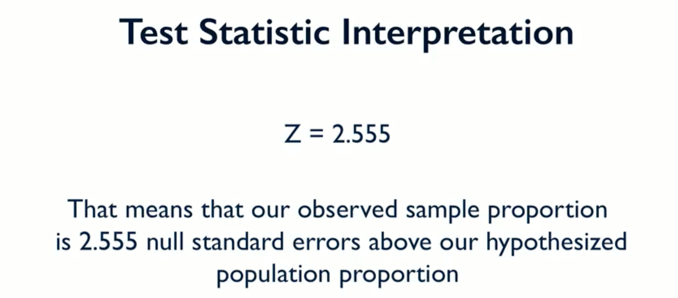

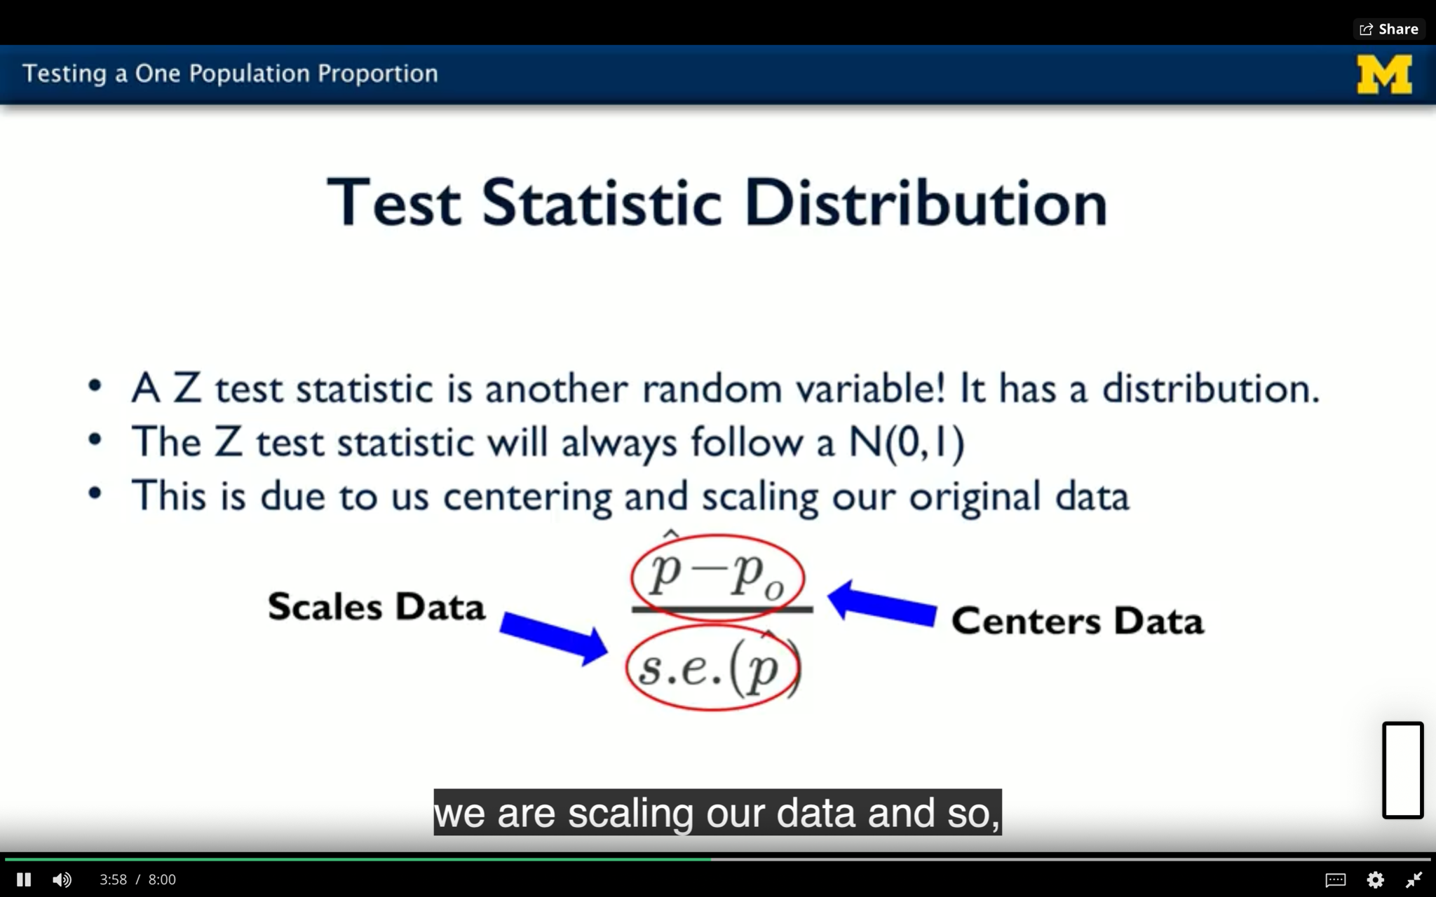

P value is the probability of getting the results as extreme as the observed results if the null hypothesis were true. If p value is greater than significance level it means that the probability of getting results this extreme is significant if p value is low it means data is in actual not what you expect it if null hypothesis were true.

Thus following 4 steps are used to test the hypothesis

1. State the hypothesis & select the significance level
2. Check assumptions
3. Calculate the test statistic and p value
4. Draw conclusions

**Testing Difference in a population proportion**

Null hypothesis should have an equal sign

Null is usually to prove the research question false

To check the assumption of at least 10 samples, we consider a common proportion.

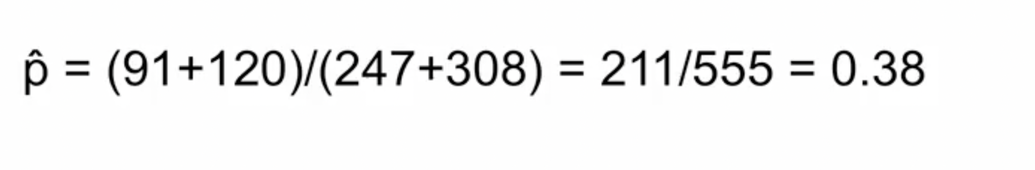For standard error,

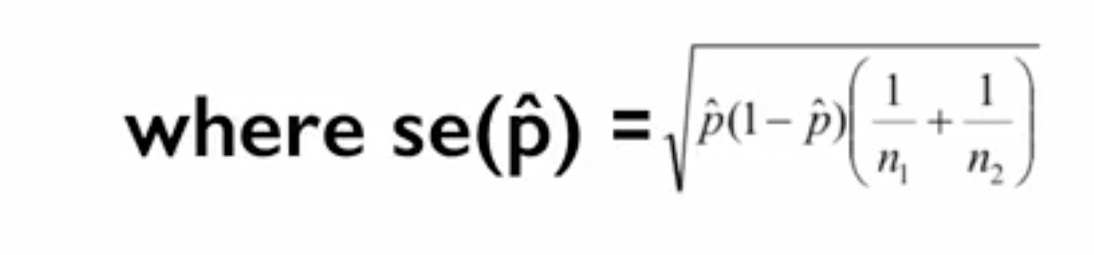

Alternative method:

**Chi square test:**

Requires two sided hypothesis i.e should be not equal to and cannot be <>

Same conclusion

Two sided hypothesis is one which is not bounded from one side

**Fisher’s exact test**

Can have one sided i.e can be <>

For smaller sample size

**p-Hacking:**

Whenever we cannot interpret p value by its mathematical meaning because of reinterpretation or edit of data after particular analysis

**Hypothesis testing for population mean:**

Here our assumption is that mean is normally distributed or sample size is large enough to apply central limit theorem

**Assignment code:**

df['column_name'].value_counts()

df.groupby(by='napping').count()

# Assumptions Consistency

### **One Population Proportion**

Sample can be considered a simple random sample

Large enough sample size ()

Confidence Interval: At least 10 of each outcome ()

Hypothesis Test: At least 10 of each outcome ()

### **Two Population Proportions**

Samples can be considered two simple random samples

Samples can be considered independent of one another

Large enough sample sizes ()

Confidence Interval: At least 10 of each outcome ()

Hypothesis Test: At least 10 of each outcome () - Where (the common population proportion estimate)

### **One Population Mean**

Sample can be considered a simple random sample

Sample comes from a normally distributed population

This assumption is less critical with a large enough sample size (application of the C.L.T.)

### **One Population Mean Difference**

Sample of differences can be considered a simple random sample

Sample of differences comes from a normally distributed population of differences

This assumption is less critical with a large enough sample size (application of the C.L.T.)

### **Two Population Means**

Samples can be considered a simple random samples

Samples can be considered independent of one another

Samples each come from normally distributed populations

This assumption is less critical with a large enough sample size (application of the C.L.T.)

Populations have equal variances – pooled procedure used

If this assumption cannot be made, unpooled procedure used

**WEEK IV:**

Good research question :

1. Population of interest
2. Is question descriptive or analytic
3. Has this question been asked previously? What additional information will it provide
4. Is data available or the tools to measure data available?

Descriptive inference examples for single variable using confidence intervals

1. What proportion of african americans age 18+ had systolic blood pressure greater than 130mg
2. What was the mean systolic blood pressure for african american age 18+

Descriptive inference examples for single variable using hypothesis testing

1. Did 33% african americans age 18+ had systolic blood pressure greater than 130mmHg
2. Was the population mean 128mmHg or different than 128mmHg

Comparing means for two independent samples

1. Did males and females have significantly different mean systolic blood pressure

Confidence intervals testing, 2 sample t test or hypothesis testing & then check assumptions

Comparing means of paired samples

1. For female adults do the 2 measured blood pressure readings vary significantly?

Confidence interval for mean difference, hypothesis testing and checking assumptions

Comparing proportions in two groups

1. Considering adults age 80+ does the number of males who smoke vary significantly from females

Form confidence interval, perform chi square test, check assumptions